Notice of Study Commencement
Class Environmental Assessment for the Rehabilitation of the Pelee Island Municipal Drinking Water Systems

The Municipality of Pelee Island (Municipality) is undertaking a Class Environmental Assessment (EA) for the proposed rehabilitation of the Pelee Island Drinking Water Systems. The purpose of this notice is to inform you of this process and invite your participation and input throughout the EA process.
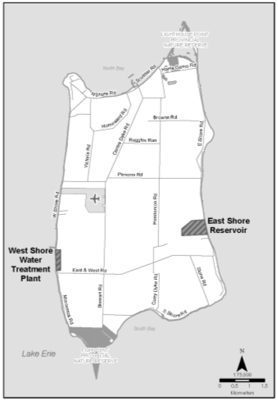
The Municipality operates two water facilities, the West Shore Water Treatment Plant (WTP) and the East Shore Reservoir which receives treated water from the West Shore WTP via truck. These are the two municipal water systems that provide Pelee Island withwater service.

A Boil Water Advisory (BWA) has been in effect for the West Shore WTP since 2010 because of issues with respect to water pressureand a lack of treated water storage. Since treated water is hauled from the West Shore WTP to the East Shore Reservoir, the East Shore Reservoir has also been under a BWA since 2010. In order to lift the BWA, the Municipality must demonstrate that the West Shore Drinking Water System can meet water pressure, treatment and treated water quality standards on a sustainable basis.

The Municipality has initiated this Class EA to identify appropriate rehabilitation strategies to address the deficiencies associated with the Water System in order to develop a long-term, cost-effective, innovative solution to provide Pelee Island with safe drinking water. The proposed project will commence as a Schedule “B” study under the Municipal Engineers Association’s (MEA) Municipal Class EA (October 2000, as amended in 2007 and 2011). Through the Class EA process, the Municipality will assess the problems and opportunities for addressing the deficiencies related to the West Shore WTP and the East Shore Reservoir, and develop and evaluate arange of alternative solutions and design concepts to improve the operation of the system .

Public and external agency consultation will be key components of this study and will include Information Packages sent to affected property owners, interest groups, agencies, and other stakeholders and posting of information on the Town’s website.

Upon completion of the study, an Environmental Study Report (ESR) documenting the Preferred Solution will be prepared for public/agency review and comment. All project information will also be available on the Town’s website.

We are interested in receiving any comments that you may have about the Class EA for the Rehabilitation of the municipal Drinking Water Systems serving Pelee Island. Should you have any questions or comments, or wish to receive additional information regardingthe project, please contact either of the following Project Team members:

Wayne Simpson, P.Eng., PMP | Ghassan Ghali, P.Eng.
Project Manager  Ontario Clean Water Agency | Project Manager  Conestoga-Rovers & Associates
2225 Erin Mills Parkway, Suite 1200 | 1195 Stellar Drive, Unit #1
Mississauga, ON L5K 1T9 | Newmarket, ON L3Y 7B8
(905) 491-3047 | (905) 830-5656
wsimpson@ocwa.com | Gghali@CRAworld.com

All personal information included in a submission – such as name, address, telephone number and property location – is collected, maintained and disclosed by the Ministry of the Environment for the purpose of transparency and consultation. The information is collected under the authority of the Environmental Assessment Act or is collected and maintained for the purpose of creating a record that is available to the general public as described in s.37 of the Freedom of Information and Protection of Privacy Act (FIPPA). Personal information you submit will become part of a public record that is available to the general public unless you request that your personal information remain confidential. For more information, please contact the Ministry of the Environment’s Freedom of Information and Privacy Coordinator at (416) 327-1434.

This Notice dated: February 10, 2014

