The Corporation of the Township of Pelee

APPLICATION FOR CONSENT
Under Section 53 of the Planning Act

Note to Applicants:
In this form, the term “subject land” means all of the land to be severed and or retained.

Completeness of the Application:
Required information is prescribed in the Schedule to Ontario Regulation 197/96 made under the Planning Act. This mandatory information must be provided with the appropriate fee. If the mandatory information and fees are not provided, the application will be returned, or may be refused for further consideration until the information and fee have been provided.

The application form also sets out other information that will assist the Committee of Adjustment and others in their planning evaluation of the consent application. To ensure the quickest and most complete review, this information should be submitted at the time of application. In the absence of this information, it may not be possible to do a complete review within the legislated time frame for making a decision. As a result, the application may be refused.

Submission of the Application:
Only one application form is required for the subject property, regardless of the number of lots proposed for severance or additional matters considered. The required fee is $500.00 for each lot to be severed, or each additional matter considered (i.e. easements, leases, etc.), and is payable in cash or cheque to the Township of Pelee. The Township may require additional fees to be paid in the event additional costs are incurred by the Township in the processing of any application.

Measurements are to be in metric units.

For Help:
If you require assistance with this application, please contact the Deputy Clerk, Secretary-Treasurer to the Committee of Adjustment:

The Corporation of the Township of Pelee
Secretary Treasurer, Committee of Adjustment
1045 West Shore Road
Pelee Island, ON N0R 1M0
Phone: (519) 724-2931
Fax: (519-724-2470
E-mail: k.digiovanni@pelee.ca

APPLICATION FOR CONSENT
Under Section 53 of the Planning Act

FILE NUMBER: B-__________
APPLICANT INFORMATION
Complete the information below. All communications will be directed to the Prime Contact with a copy to the Owner.

Note: If additional space is required for owner(s) information, please attach a separate sheet containing the information.
1. Registered Owner(s)
Name:

Address: |  | City: |  | Postal Code:
Phone:

Fax:

E-mail:

2. Agent Authorized by the Owner to file the Application (if applicable)
Name:

Address: |  | City: |  | Postal Code:
Phone:

Fax:

E-mail:

3. Ontario Land Surveyor (if applicable)
Name:

Address: |  | City: |  | Postal Code:
Phone:

Fax:

E-mail:

4. Which of the above is the Prime Contact? Owner Agent Surveyor

5. Name and address of any mortgagees, holders of charges or other encumbrances:
6. a) Type and purpose of proposed transaction:
Lot Creation Number new lots created:________
Surplus Farm Dwelling | Addition to lot |  | Mortgage
Lease | Easement |  | Right-of-Way
Validation of Title | Other

6. b) Name of person(s) if known, to whom land or interest in land is to be transferred, leased or mortgaged (purchaser, lessee, mortgagee):
Name of Person(s):
Specify Nature of Relationship with Owner:

6. c) If a lot addition, identify the assessment roll no., or PIN # and the property owner of the lands to be enlarged.
6. d) If this application is to sever a farm dwelling surplus to a consolidated farm operation, explain how it qualifies as a surplus dwelling. Refer to Schedule “A”.
6. e) Are there any barns located within 500 m (1640 ft) of the subject of this application?
 | YES |  | NO
6. f) If you answered “YES” to 6 e) are these barns:
i) Now used for livestock? YES NO
ii) Capable of being used for livestock? YES NO
6. g) If you answered “YES” to 6 e) describe the type and number of livestock and/or poultry, the housing capacity of the barn and the manure system:
6. h) How many tillable hectares are within the lands where the livestock facility is located?
Tillable hectares:

LOCATION OF THE LAND AND EASEMENTS (check appropriate space).

7. a) Legal Description
Lot(s) No._________________________________________________
Registered Plan No._______________________________________
Reference Plan and Part No._______________________________
Municipal (911#) Address__________________________________
Assessment Roll No.________________________________________

7. b) Easements affecting the subject land and a description of each easement and its effect:
Easement Description

Easement Description

DESCRIPTION OF LAND
(if additional space is required, please attach a separate sheet containing the required information)
8. a) Land Intended to be Severed:
Frontage (m) |  | Depth (m) | Area (m²) |  |  | Existing Use |  |  |  | Proposed Use
8. b) Land Intended to be Retained:
Frontage (m) |  | Depth (m) | Area (m²) |  |  | Existing Use |  |  |  | Proposed Use
Number of Existing Buildings/Structures:  Use of Existing Buildings/Structures (specify): |  |  |  |  |  |  | Number of Proposed Buildings/Structures:  Proposed Use of Buildings/Structures (specify):
8. c) Access
Type of road access for severed land: (check appropriate box)
 | Municipal Road seasonal |  |  |  | Municipal Road year-round |  |  |  | Other (Specify)
Type of road access for retained land: (check appropriate box)
 | Municipal Road seasonal |  |  |  | Municipal Road year-round |  |  |  | Other (Specify)
8. d) Water Supply
Type of water supply proposed for severed land: (check appropriate box)
 | Publicly owned and operated piped water system |  |  |  | Privately owned and operated well |  |  |  | Other (Specify)
Type of water supply proposed for retained land: (check appropriate box)
 | Publicly owned and operated piped water system |  |  |  | Privately owned and operated well |  |  |  | Other (Specify)
8. e) Sewage Disposal
Type of sewage disposal proposed for severed land: (check appropriate box)
 | Publicly owned and operated sanitary sewage system |  |  |  | Privately owned and operated individual septic system |  |  |  | Other (Specify)
Type of sewage disposal proposed for retained land: (check appropriate box)
 | Publicly owned and operated sanitary sewage system |  |  |  | Privately owned and operated individual septic system |  |  |  | Other (Specify)

OFFICIAL PLAN AND ZONING
9. Official Plan
a) What is the land use designation of the site in the Official Plan? (Please refer to all relevant Schedules in the Official Plan)

b) Does the proposal conform to the Official Plan? YES NO

c) If No, has a separate application for an Official Plan Amendment been made?

No YES FILE No.: ______________________ Status:___________________________

10. Zoning By-law
a) What is the zoning of the subject land? (Please refer to all relevant Schedules in the Zoning By-law)

b) Does the proposal comply with the existing Zoning? YES NO

c) If No, has a separate application for a rezoning been made?

NO YES FILE No.:_______________________ Status:___________________________

11. Land Previously Severed from Subject Land
a) If known, has the subject land been the subject of an application for approval of a plan of subdivision under
Section 51 of the Planning Act or a consent under Section 53 of the Planning Act?

YES NO

b) If YES, provide the application file number and decision made on the application.

c) If this application is a re-submission of a previous consent application, describe how it has been changed from the original application.

d) Has any land been severed from the parcel originally acquired by the owner of the subject land?

Yes No

e) If YES to 11 d), please provide:

Date of Transfer:

Name of Transferee:

Use(s) of Severed Land:

12. Other Applications under the Planning Act
Is the subject land currently the subject of any other application under the Planning Act?

YES NO Unknown
Approval of a plan of subdivision | File #__________________ | Status________________________
Consent | File #__________________ | Status________________________
Official Plan Amendment | File #__________________ | Status________________________
Zoning By-law | File #__________________ | Status________________________
Minor Variance | File #__________________ | Status________________________
Other (specify) | File #__________________ | Status________________________

SKETCH
13. A sketch of the following, in metric units, is required:
a)  b)  c)  d)  e)  f)  g)  h)  i) | The boundaries and dimensions of any land abutting the subject land that is owned by the owner of the subject land;  The location of building and structures on the land to be severed and retained and the distance to lot lines;  The approximate distance between the subject land and the nearest Township lot line or landmark such as a bridge or road intersections:  The boundaries and dimensions of the subject land, the part that is intended to be severed and the part that is intended to be retained;  The location of all land previously severed from the parcel originally acquired by the current owner of the subject land;  The approximate location of all natural and artificial features (e.g. buildings, roads, watercourses, drainage ditches, banks of drains, dikes, wetlands, wooded areas, wells and septic tanks) that,  i) are located on the subject land and on land that is adjacent to it, and  ii) in the applicant’s opinion, may affect the application;  The current uses of land that is adjacent to the subject land (e.g. residential, agricultural, or commercial);  The location, width and name of any roads within or abutting the subject land, indicating whether it is an unopened road allowance, a public travelled road, a private road or a right-of-way;  If access to the subject land will be by water only, the location of the parking and boat docking facilities to be used; and  The location and nature of any easement affecting the subject land.

Please see example sketch attached to this application.

PROVINCIAL POLICY INFORMATION REQUIREMENTS
14. Is the application consistent with policy statements issued under Subsection 3(1) of the Planning Act?
Identify policies from the 2014 Provincial Policy Statement (PPS) that you intend to use to support your application.
(Refer to Schedule B) Note: if additional space is required, please attach a separate sheet containing this information.

OWNER’S AUTHORIZATION
15. This must be completed by the owner if the OWNER IS NOT FILING THE APPLICATION
Note: If there are multiple owners, an authorization letter from each owner (with dated, original signature) is required OR each
owner must sign the following authorization.
I, (we) _______________________________________________________________________, being the registered owner(s) of the
Print (name(s) of owner, individuals or company)

Subject lands, hereby authorize ________________________________________________________ to prepare and submit an
Print (name of agent and/or company (if applicable))

Application for Consent for approval.

_______________________________________________________  Signature | _______________________________________________________  Day Month Year
IMPORTANT:

- If the Owner is an incorporated company, the company seal (if there is one) shall be applied in the authorization block above.

APPLICAN’T’S DECLARATION
16. This must be completed by the Person filing the Application for the proposed development site.
I, ____________________________________________________ of the _________________________________________________
Print (name of applicant) Print (Name of City, Town, Township, etc.)

In the Region/County/District of __________________________________________ solemnly declare that all of the

Statements contained in this Application for Consent at _________________________________ and all supporting
(Municipal Address or Legal Description)

documents and plans are true and complete, and I make this solemn declaration conscientiously believing it to

be true, and knowing that it is of the same force and effect as if made under oath, and by virtue of the Canada

Evidence Act.

For the purposes of the Municipal Freedom of Information and Protection of Privacy Act, I authorize and consent to

the use by or disclosure to any person or public body of any personal information in this application that is collected

under the authority of the Planning Act for the purpose of processing your application.

I hereby give permission for staff and/or Committee Members to visit the site for inspection.

Declared before me  At the _______________________________________  (City, Town, Township, etc.)  of __________________________________________  In the _______________________________________  (Region, County, District)  of___________________________________________  this__________day of _____________, 20_________ | _______________________________________________________  Signature  _______________________________________________________  Please Print name of Applicant
OWNER’S OR APPLICANT’S CONSENT DECLARATION
In accordance with the provisions of the Planning Act, it is the policy of the City Planning Department to provide public access to all development applications and supporting documentation.

In submitting this development application and supporting documentation, I ____________________________________
The owner/the authorized applicant/the authorized agent, hereby acknowledge the above-noted policy and provide my consent, in accordance with the provisions of the Municipal Freedom of Information and Protection of Privacy Act, that the information on this application and any supporting documentation provided by myself, my agents, consultants and solicitors, will be part of the public record and will also be available to the general public.

I hereby authorize the Township to post a Change of Use sign and municipal staff to access the subject site for purposes of evaluation of the subject application.

_______________________________________________________  Signature  OWNER/APPLICANT’S INFORMATION (Mandatory)  Print Name:______________________________________________  Mailing Address:__________________________________________  __________________________________________  E-mail Address:___________________________________________  Telephone No._____________________ Fax No.________________ | _______________________________________________________  Day Month Year

APPLICATION FOR CONSENT
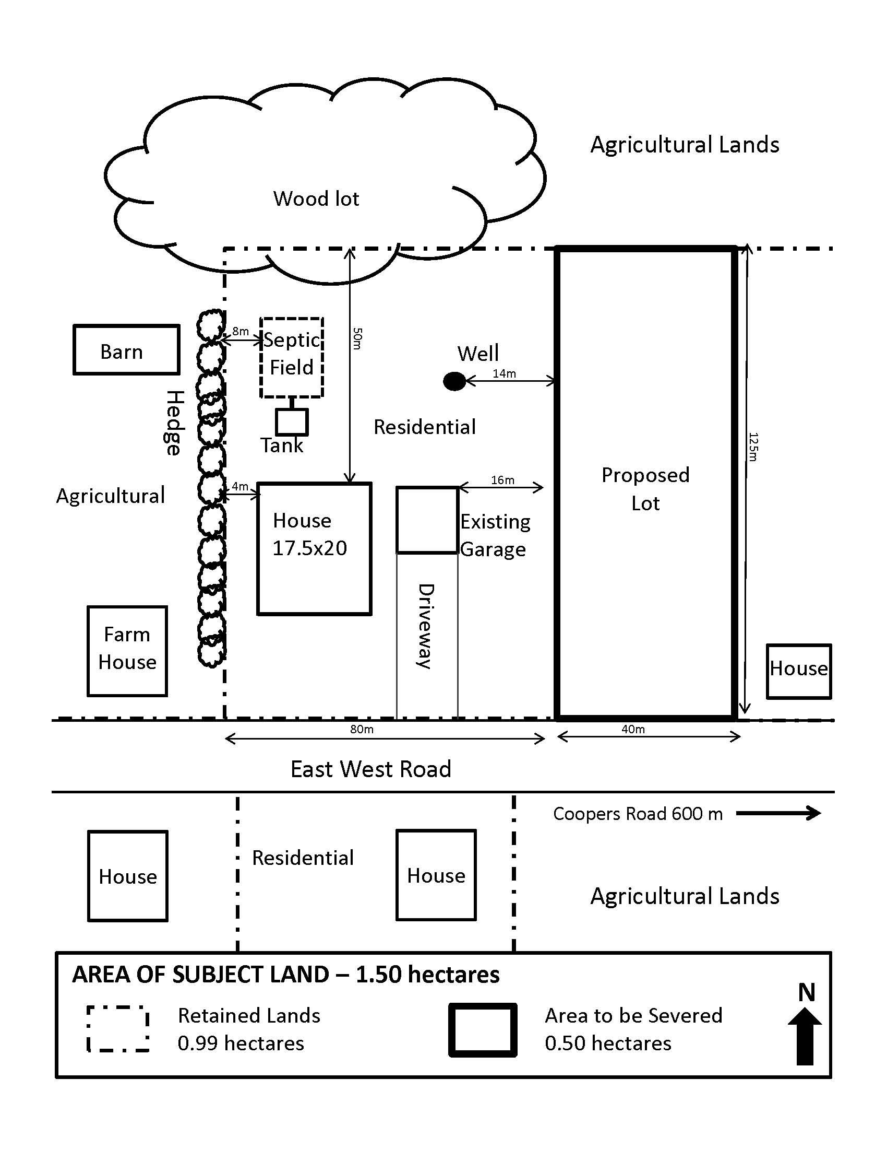
EXAMPLE OF REQUIRED SKETCH

SCHEDULE ‘A’

TOWNSHIP OF PELEE
Proposed Severance of a Farm Dwelling Made Surplus by Farm Consolidation
(To be completed by the Owner of the consolidated farm)

Note: For surplus farm dwelling severances, new residential dwellings are prohibited on any vacant parcel of farmland created.

PREFACE: Provincial policies discourage residential lot creation in prime agricultural areas and only allow such severances to be considered for dwellings made surplus to a farming operation as a result of farm consolidation. By filling out this form, the farm owner is providing information needed to determine if a proposed severance is consistent with these policies.

1. Consent Application File No.____________________________

2. Name of Farm Owner_____________________________________________________________

3. Main farm base of operations:

Location: Municipality________________________________ Lot, Concession_________________________________

Street Address – (911#)_________________________________________________________________________________

Date of Purchase:_______________________________________________________________________________________

Type(s) of farming (e.g. cash crop, dairy, etc.)____________________________________________________________

4. List the following information for all lands forming part of the farm operation:
Location of Land |  | Land Area (ac or ha) | No. Of Dwellings
Pelee Township | Owned
 | Leased
Other Municipalities | Owned
 | Leased
 | Total

5. Provide an explanation of why the existing dwelling located on the property consolidated (or proposed for
Consolidation) with the farm operation is surplus to the current and future needs of the farm operation, and is proposed for severance. (Consider future needs of farm family, farm labour, estate planning, rental potential, etc.)

Having considered both current and future needs, I declare that the dwelling proposed to be severed is surplus to the needs of this farm operation.

______________________________________________ _______________________________________
Signature of Farm Owner Date

SCHEDULE ‘B’

PROVINCIAL POLICY INFORMATION REQUIREMENTS

FEATURES OR DEVELOPMENT CIRCUMSTANCES | YES | NO | UNKNOWN | IF FEATURE: SPECIFY DISTANCE IN METRES | POTENTIAL INFORMATION NEEDS
Non-farm development near designated urban areas or rural settlement areas |  |  |  |  | Demonstrate sufficient need within 20-year projections and that proposed development will not hinder efficient expansion of urban areas or rural settlement areas.
Land Fill Site |  |  |  |  | Address possible leachate, odour, vermin and other impacts.
Electric transformer station |  |  |  |  | Determine possible impacts within 200 metres.
High voltage electric transmission line |  |  |  |  | Consult the appropriate electric power service.
Transportation and infrastructure corridors |  |  |  |  | Will the corridor be protected? Noise Study prepared?
Mineral aggregate resource areas |  |  |  |  | Will development hinder access to the resource or the establishment of new resource operations?
Mineral aggregate operations |  |  |  |  | Will development hinder continuation of extraction?  Noise and Dust Study completed?
Existing pits and quarries |  |  |  |  | Will development hinder continued operation or expansion?  Noise and Dust Study completed?
Mineral and petroleum resource areas |  |  |  |  | Will development hinder access to the resource or the establishment of new resource operations?
Significant wetlands or potentially significant wetlands |  |  |  |  | Provide Environmental Impact Study.
Significant ravine, valley, river and stream corridors and significant portions of habitat of endangered and threatened species |  |  |  |  | Provide Environmental Impact Study.
Significant fish habitat, wildlife habitat, woodlands, valley lands, areas of natural and scientific interest. |  |  |  |  | Provide Environmental Impact Study.
Sensitive groundwater recharges areas, headwaters and aquifers. |  |  |  |  | Demonstrate that groundwater recharge areas, headwaters and aquifers will be protected.
Significant landscapes, vistas and ridge-lines, significant built heritage resources and cultural heritage landscapes. |  |  |  |  | Development should conserve significant landscapes, vistas and ridge-lines, significant built heritage resources and cultural heritage landscapes.
Significant archaeological resources |  |  |  |  | Assess development proposed in areas of medium and high potential for significant archaeological resources. These sources are to be studied and preserved, or where appropriate, removed, catalogued and analyzed prior to development.
Erosion hazards |  |  |  |  | Determine feasibility within the 1:100 year erosion limits of ravines, river valleys and streams.
Floodplains |  |  |  |  | Determine limit of Development or where a Special Policy Area (SPA) is in effect, development must meet the Official Plan policies.
Hazardous sites |  |  |  |  | Slope Study, Flood line Study
Contaminated sites |  |  |  |  | Assess an inventory of previous uses in areas of possible soil contamination
Prime agricultural land |  |  |  |  | Demonstrate need for use other than agricultural and indicate how impacts are to be mitigated
Agricultural operations |  |  |  |  | Development to comply with the Minimum Distance Separation Formulae and O.P. policies.

